Enterprise Software Platforms

# HW #1 - Ansible

| NAME | SJSU ID EMAIL ID |
| --- | --- |
| Ninad Sanjay Marathe | 016597503 ninadsanjay.marathe@sjsu.edu |

**Launching 3 EC2 instances on Amazon Web Services:**

* Go to https://aws.amazon.com/ec2/ and create a free tier account with your username and password.
* In the menu, select EC2 in the search bar and go to EC2 Dashboard
* Select Launch Instance in the EC2 Dashboard
* In names and tags, enter a name for the VM
* Select the operating system that you want under the amazon machine image, for instance, Ubuntu 22.04
* Go to the instance type and select t2.micro
* After that, in the key-value pair, enter a name for the key pair file and download it in your system.
* Under network settings, create a security group that allows HTTP and SSH traffic.
* Configure Storage with 8 GBS
* Under “number of instances,” enter 3
* Launch the instances.

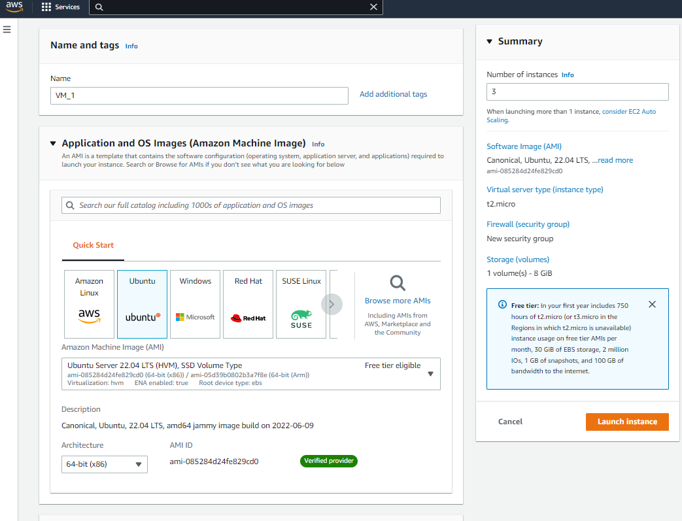

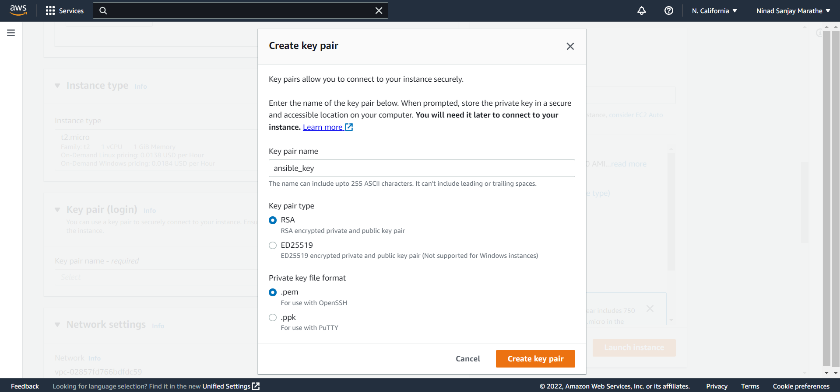

Creating the key pair, In our case, we have created key pair named ansible_key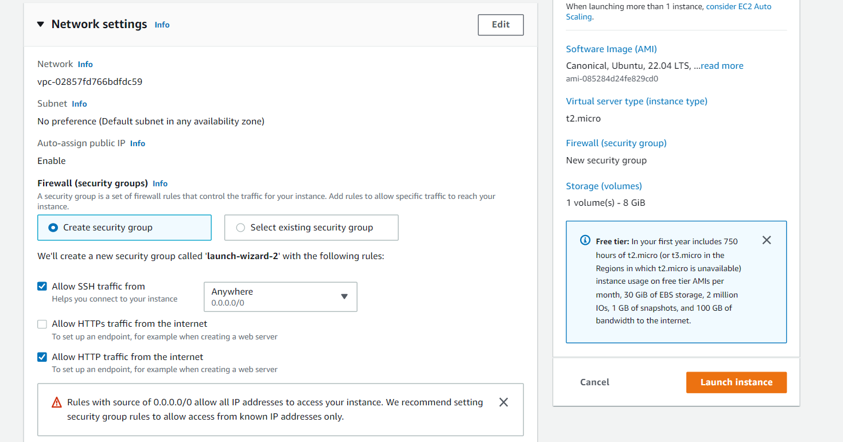

Create a security group, and select allow SSH and HTTP traffic.

 Select the OS as Ubuntu 22.04.

The above image is for the three instances that are running. They are named as VM_1, VM_2, VM_3.

**Connecting to EC2 instance using ssh:**

In the local command prompt, type scp -i path\ ansiblekey.pem -r path\ ansiblekey.pem ubuntu@dns-name :/home/ubuntu/.ssh/ansiblekey.pem

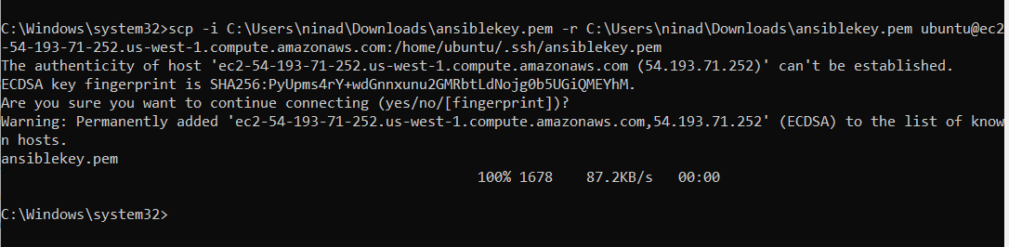

**Setting up ansible:**

* In EC2 Instance connect to the master server, Install python using the command:

sudo apt-get install python 3.6

* Install pip using these commands:

curl https://bootstrap.pypa.io/get-pip.py -o get-pip.py

python3 get-pip.py --user

* Install ansible using this command:

python3 -m pip install --user ansible

* Check the version by typing:

ansible --version

The below are the screenshots for the same.

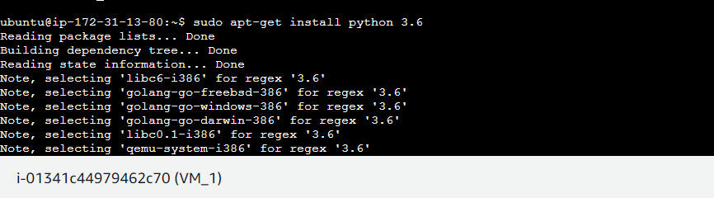

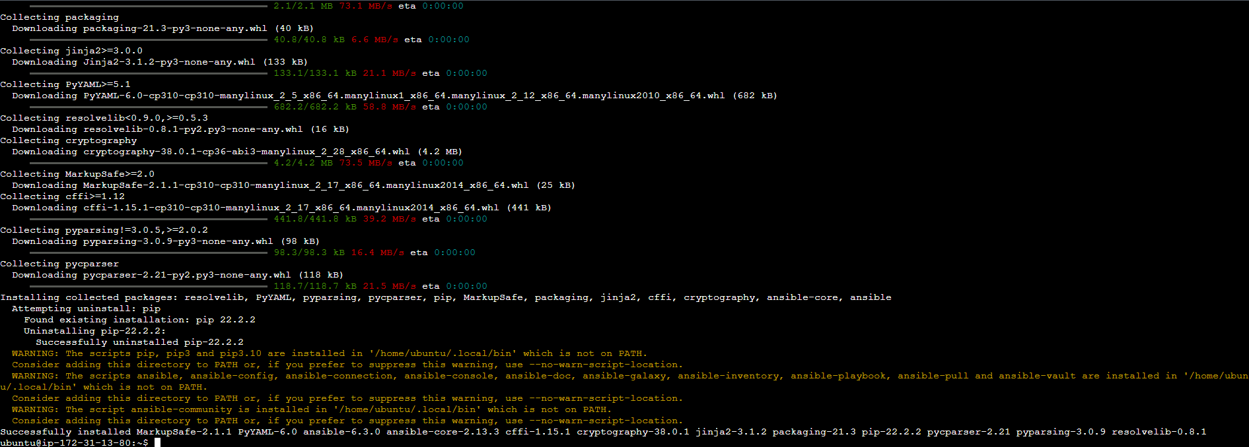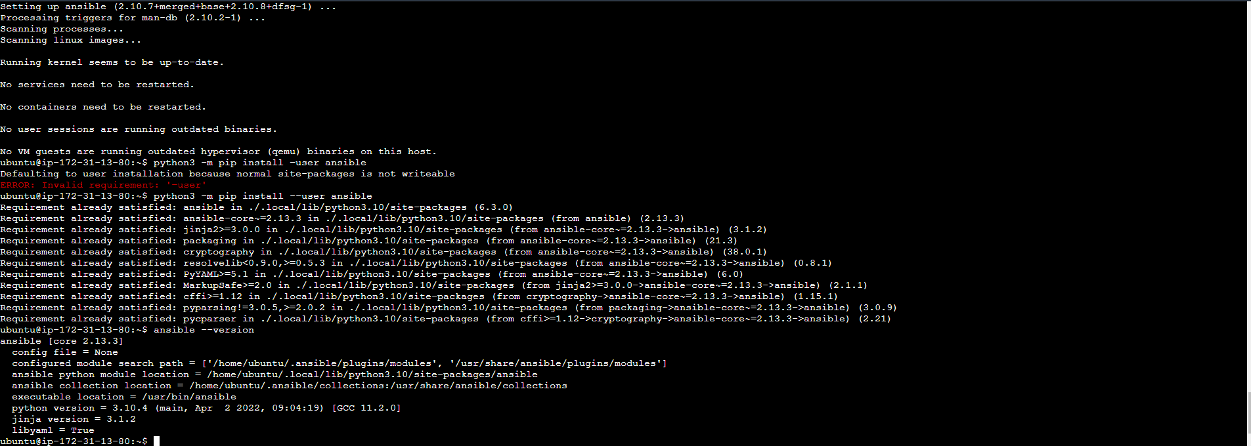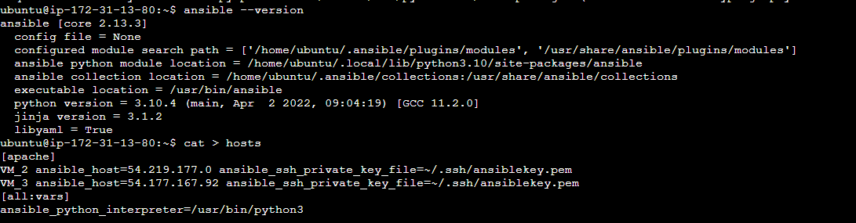

Thus, ansible is installed.

**Creating a playbook for deployment:**

Now, we are going to create a playbook to deploy apache server:

Writing the hosts file:

* Add the following code in your EC2 Instance Connect

[apache]

vm1 ansible_host=ip_addr ansible_ssh_private_key_file=~/.ssh/keypair.pem

vm2 ansible_host=ip_addr ansible_ssh_private_key_file=~/.ssh/keypair.pem

[all:vars]

ansible_python_interpreter=/usr/bin/python3

Here VM1 and VM2 are the names of the target hosts, ansible_host = ip_addr is the ip address of the hosts and ansible_ssh_private_key_file=~/.ssh/keypair.pem is the private key by ssh.

After that, go to the EC2 Instance, click on connect and enter the following commands as said below:

cat > hosts

Once done, create a file named apache_install.yml

And add the following code:

-/ hosts: apache

become: true

tasks:

- name: install apache2

apt: name=apache2 update_cache=yes state=latest

- name: Copy your index file

template:

src: "index.html"

dest: "/var/www/html/index.html"

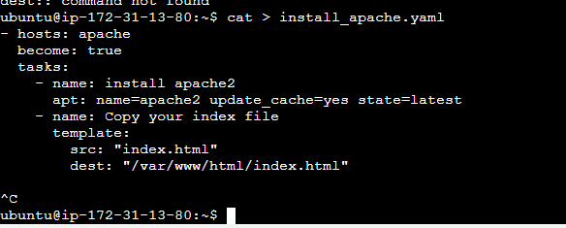

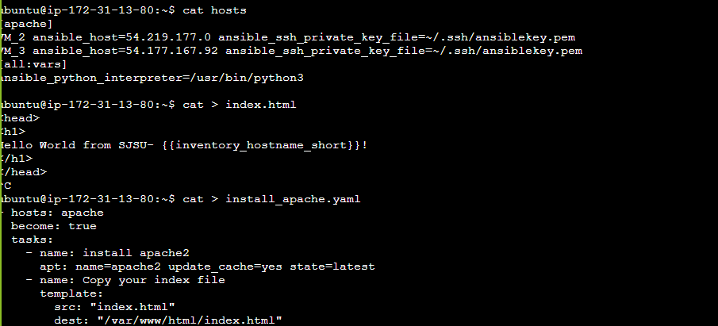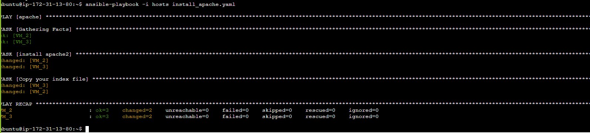

Thus, we have installed apache. We can see the “Hello World “ message displayed on the respective IP addresses. Below are the screenshots of the messages displayed.

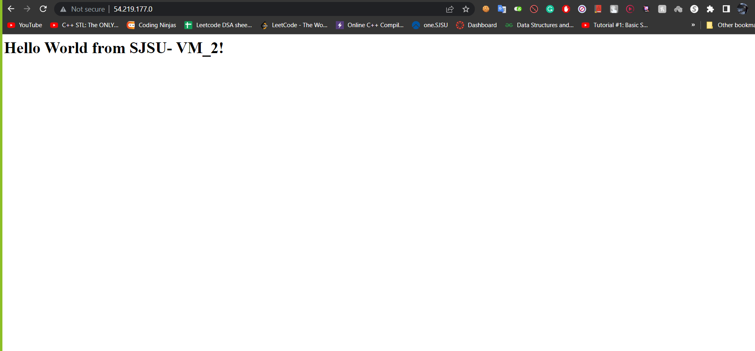

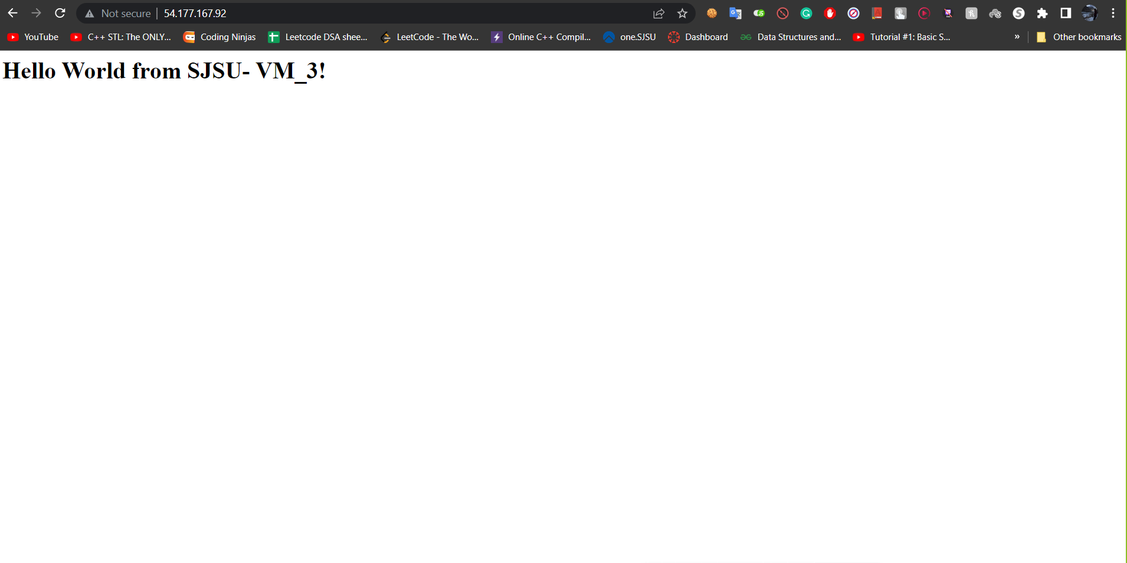

**Un-deploying apache web server process:**

Create a file named uninstall_apache.yml and add the code given below

---

- hosts: apache

become: true

tasks:

- name: uninstall apache2

apt: name=apache2 autoremove=yes state=absent

Once done, go to EC2 terminal and add the command ansible-playbook - i hosts uninstall_apache.yml

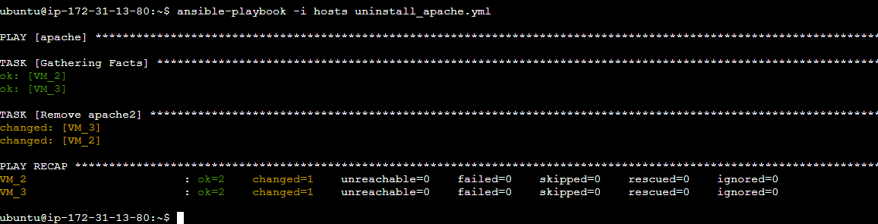

After it’s uninstalled, you won’t be able to access the web server. Below are the screenshots for the same

